JMeter:

Using the testing tool JMeter we setup two different thread groups one being for UTSA and another setup for Google. For UTSA thread group we’re using ten users with a ten second Ramp-Up Period which means there’s a one second delay between starting users using one as the loop count which results to 40 samples. Google’s thread group was much more exagerrated with 100 users with a Ramp-Up Period of two and loop count of ten which results to 1,000 samples.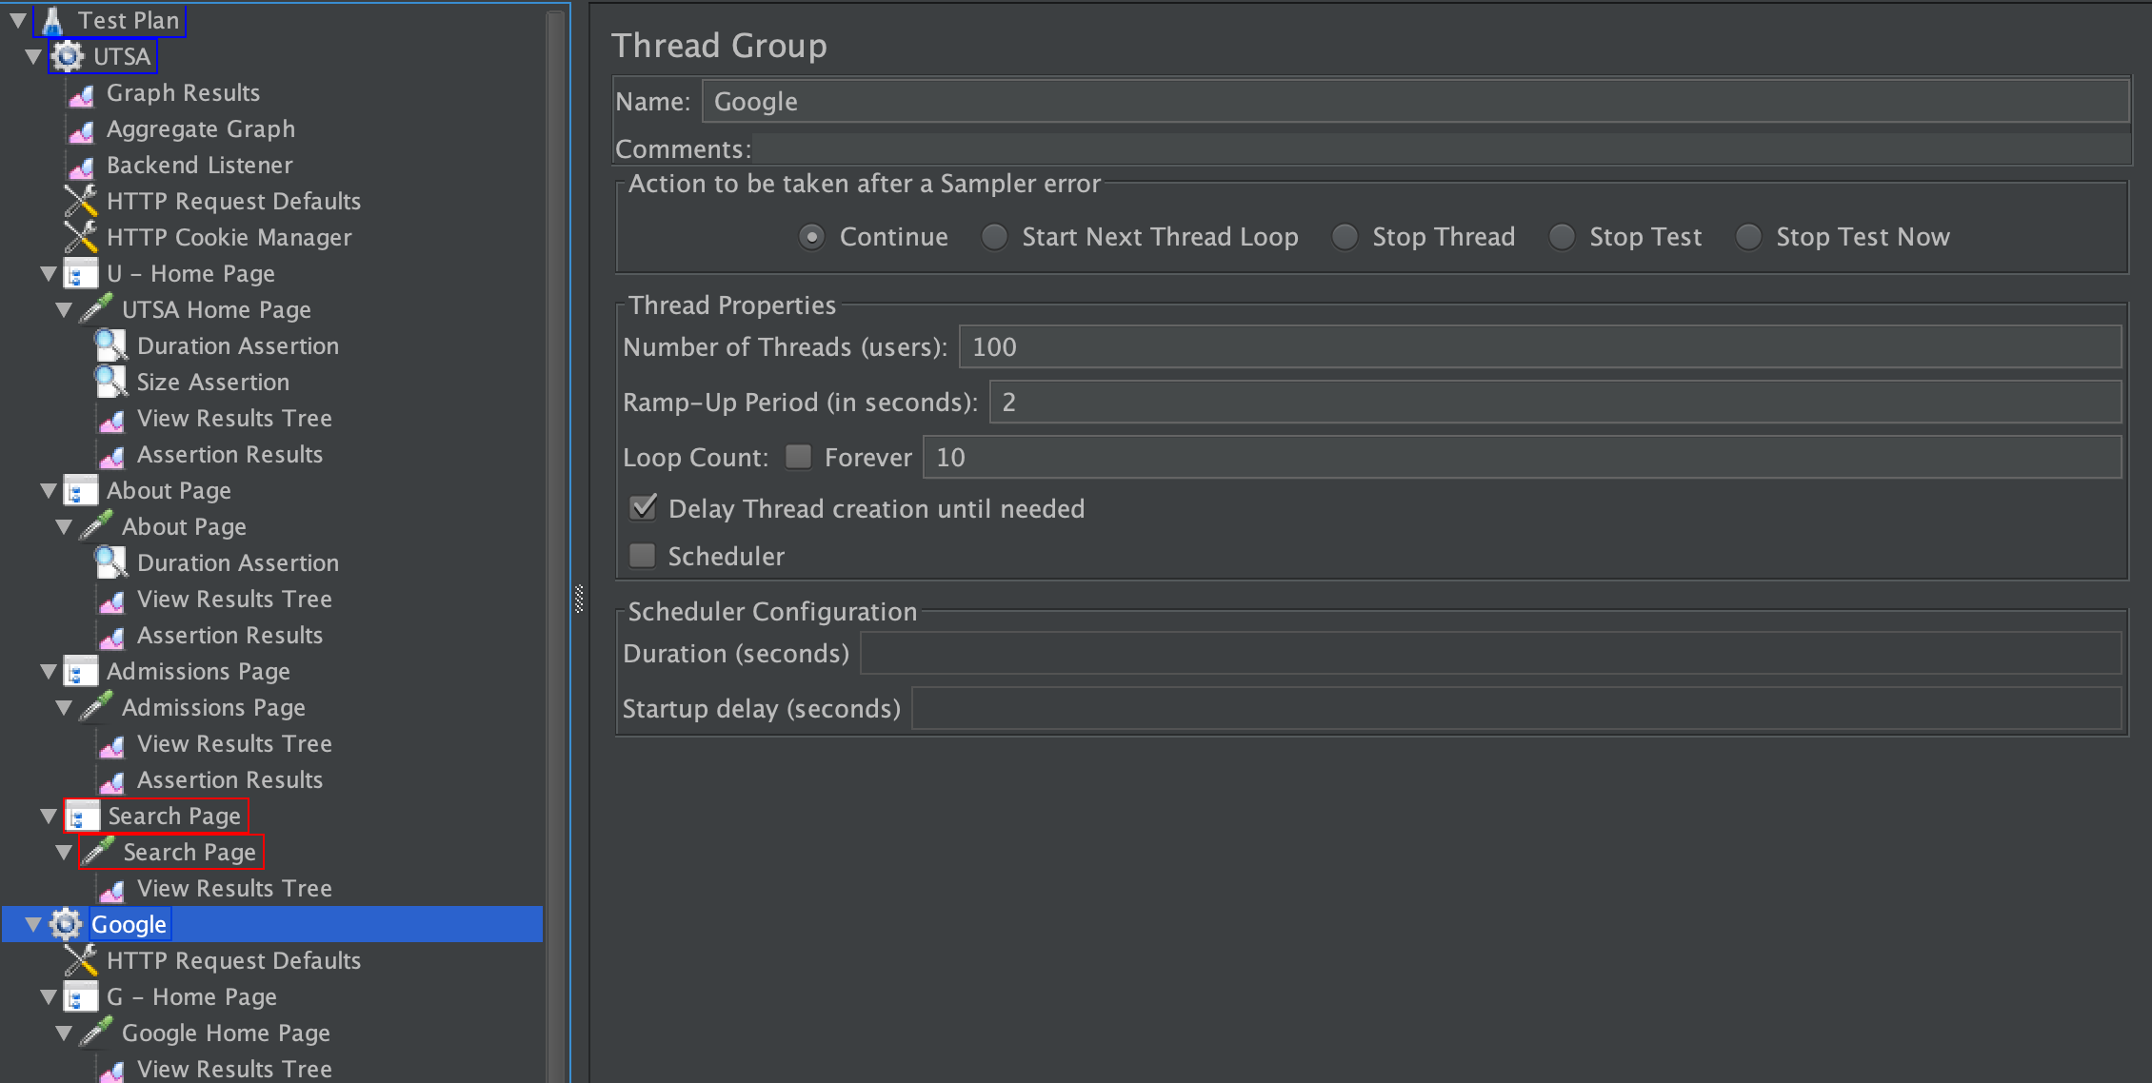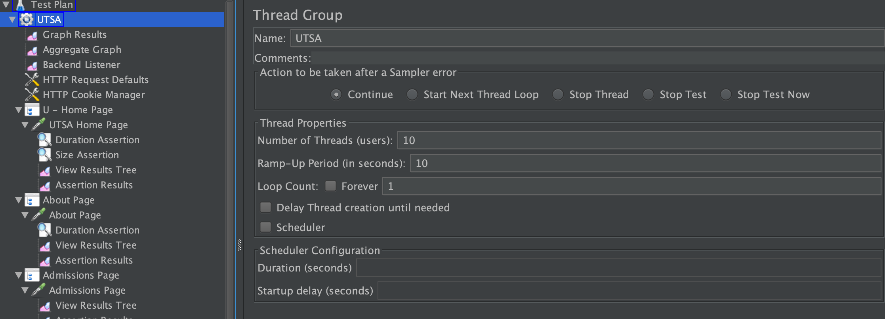

In both thread groups I first setup “HTTP Request Defaults” so I could avoid retyping the domain path. Next I included “HTTP Cookie Manager” incase my HTTP Requests response contains a cookie the Cookie Manager will automatically store that cookie for later use to that particular website. I then decided to use Transaction Controllers which generates an extra sample that measures the overall time taken to preform any nested test elements. For the Transaction Controller I made sure to check the option to generate the parent’s sample. I have labeled each Transaction Controller according to the HTTP Request which uses the GET method to only return data. There are many other methods one can use with HTTP Request such as the POST method which could be used to submit data to the target resourse and is commonly used to assist with log ins. Another common HTTP Request method is the CONNECT method which establishes a tunnel to the target resourse. Under some HTTP Request you will see Duration Assertions which throw an error if the Duration Assertion exceeds 30 milliseconds. I also included some Size Assertions which allows you to identify if certain files are too big or small in bytes. Now I will attempt to explain my Graph Results. The Throughput depicts the amount of data being sent gradually increasing as this is calculated as requests/unit of time which starts from the first sample to the end of the last sample. The Throughput seems obvious as the load on the server increases as the Thread Group Google loops through it’s number of threads. The deviation is relatively low which tells you how densely are clustered around the mean. Being that the deviation is low we won’t have to worry too much in regards to performance.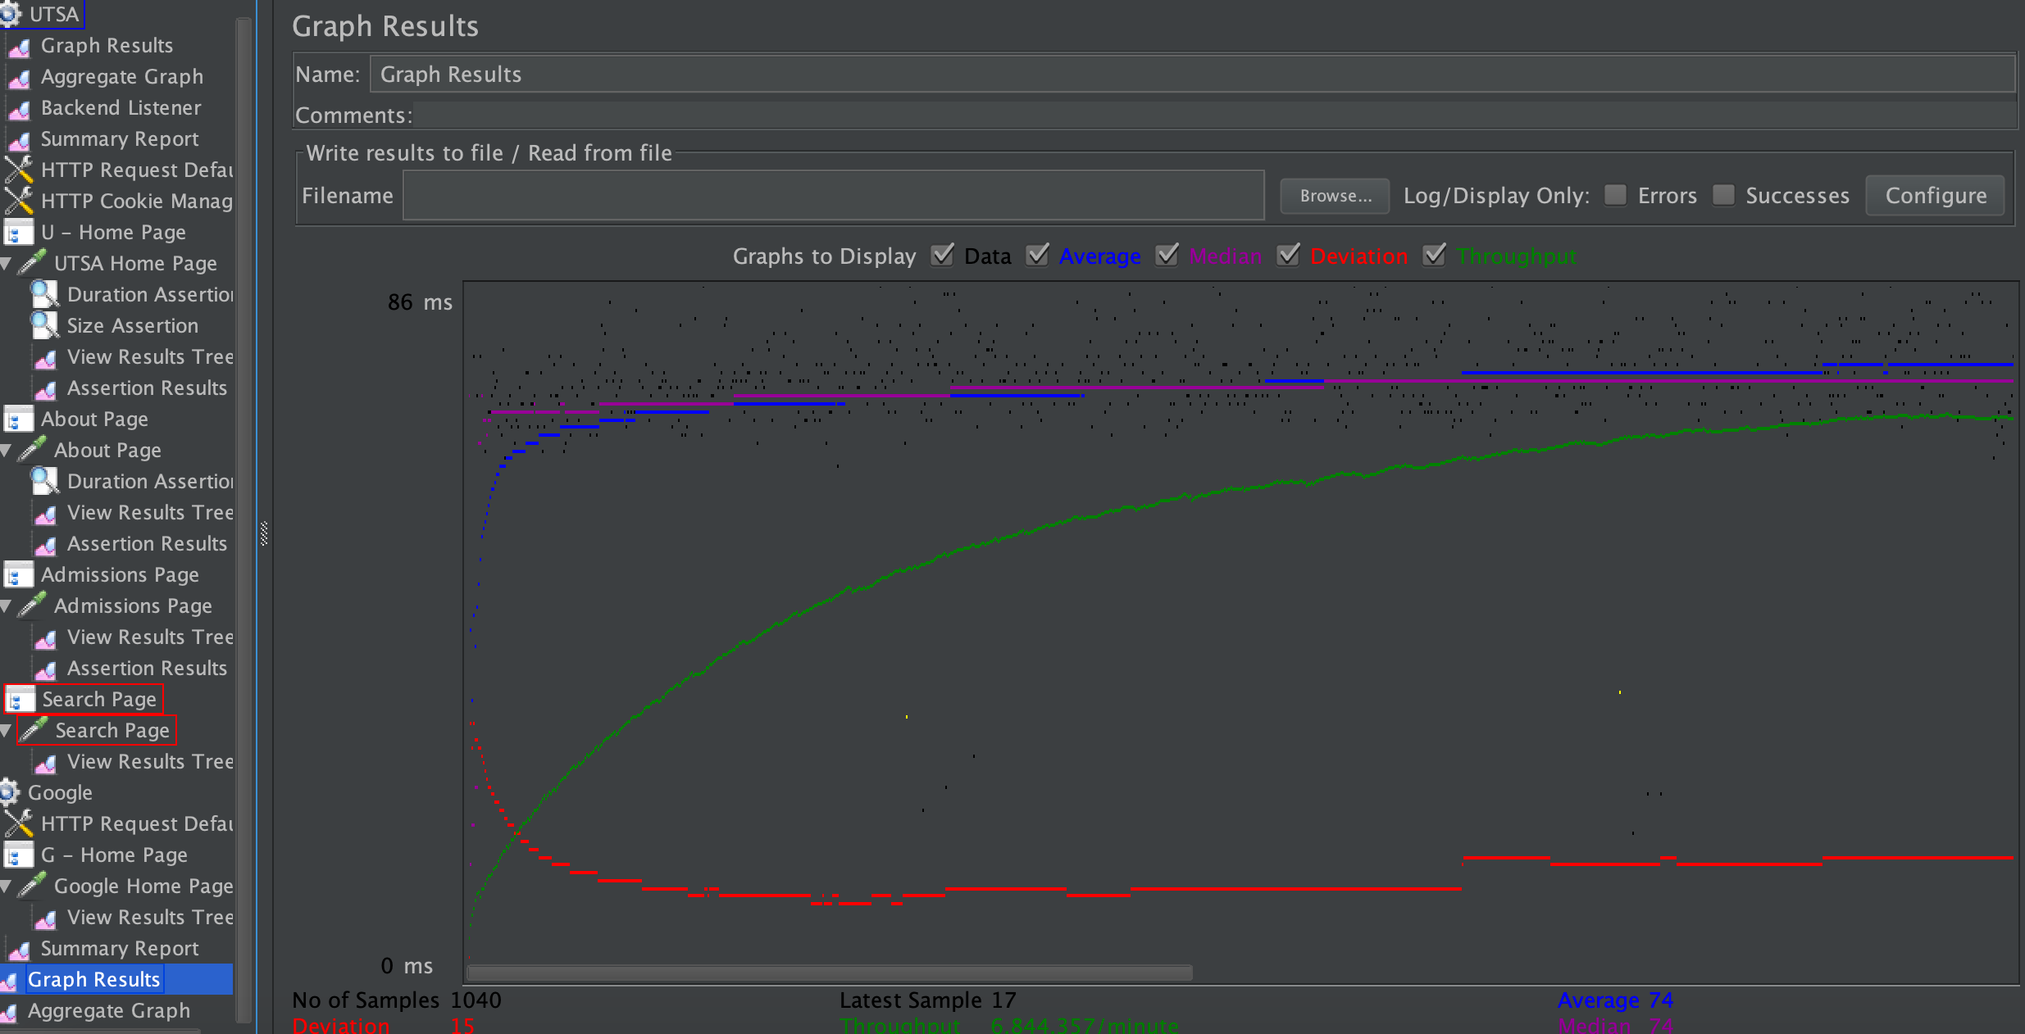

Randoop:

